EXPERIMENT 5

AIM:
Study of β-spectroscopy using Sr⁹⁰ and Na²²

SOURCES:
Sr⁹⁰ and Na²²
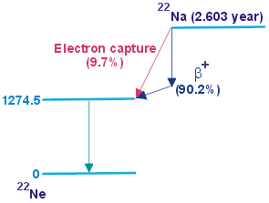

Figure 1: Decay Scheme of Na-22

THEORY:
1) The Decay Process:
- Sr-90 undergoes β⁻decay as follows:
n p + e⁻ + ${\overline{ν}}_{e}$

n – neutron
p – proton
e⁻ - electron (called the β⁻ particle)
${\overline{ν}}_{e}$ – antineutrino

- Na-22 undergoes β⁺ decay as follows:

p n + e⁺ + $ν_{e}$

n – neutron
p – proton
e⁺ - positron (called the β⁺ particle)
$ν_{e}$ – neutrino.

- Since the decay energy, known as the Q-value is shared among three particles (the daughter nucleus, the beta particle, and the neutrino/antineutrino), the beta particle can be emitted with a range of kinetic energies from zero up to the maximum Q-value.

2) The Magnetic Spectroscope:
It is primarily used to analyze the momentum and kinetic energy of fast-moving charged particles, especially beta particles. Its operation is based on the fundamental Lorentz force acting on a moving charge.
- A charged particle (with charge q and mass m) is emitted from a source and enters a region with a uniform magnetic field (B).
- The magnetic force, F = q (v x B), is always perpendicular to the particle's velocity v, causing the particle to follow a circular path.
- By setting the magnetic force equal to the centripetal force, we derive the key relationship for the particle's momentum (p):

$$qvB=\frac{mv^{2}}{r}$$
$$p=qBr$$

- In a magnetic spectroscope, the magnetic field strength (B) is known, and by measuring the radius of curvature (r) of the particle's path, we can precisely determine its momentum (p).

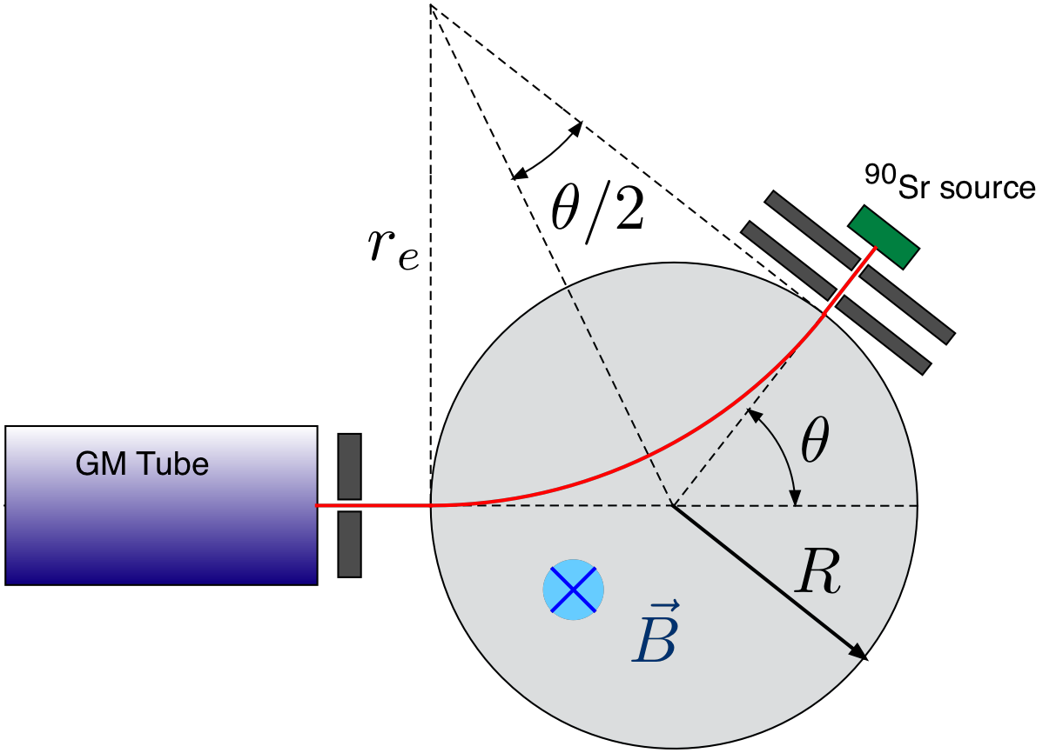
Figure 2: Magnetic Spectrometer

3) Relativistic Energy:
- For a particle with rest mass m₀ and momentum p, the fundamental relativistic relationship between its Total Energy (E) and its momentum is:
$$E^{2}={\left(pc\right)}^{2}+{\left(m_{0}c^{2}\right)}^{2}$$

E = Total Energy = Rest energy + Kinetic Energy
p = Relativistic momentum measured by magnetic spectroscope (p = qBr)
c = Speed of light
- The Kinetic Energy (KE) is defined as the difference between the particle's total energy (E) and its Rest Energy (E₀). Substituting all the values:

KE = E – E₀ = $\sqrt{{\left(ⅇBrc\right)}^{2}+{\left(m_{0}c^{2}\right)}^{2}}-m_{0}c^{2}$

- Beta particles (electrons and positrons) are emitted with a wide range of energies, often reaching velocities very close to the speed of light (c). That is why relativistic correction is required.
- The standard values for the parameters are:

r = 50 mm
c = 3 x 10⁸ m/s
m₀ = 9 x 10⁻³¹ kg
e = 1.6 x 10⁻¹⁹ C
B = x mT = 10⁻³ x T

Substituting all of this into the formula:

KE = $\sqrt{{\left(ⅇBrc\right)}^{2}+{\left(m_{0}c^{2}\right)}^{2}}-m_{0}c^{2}$

KE (keV) = 10 x $(\sqrt{2.25x^{2}+2617}-51.19)$

OBSERVATIONS:
The entire data for the experiment for both Sr-90 and Na-22 can be found at: https://docs.google.com/spreadsheets/d/1M59TUarT7aPUf3LTD2lQmzyCyWwtFuWpVhaW8bvCSFI/edit?usp=sharing
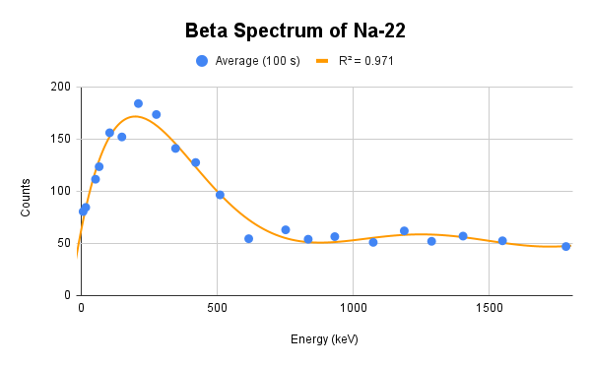
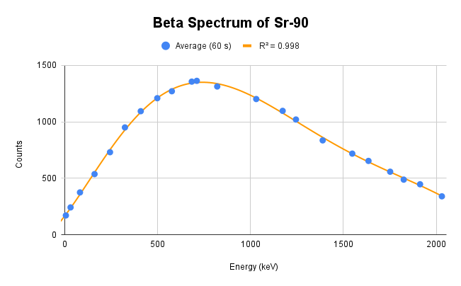
Figure 4: Beta Spectrum of Na-22
Figure 3: Beta Spectrum of Sr-90
ANALYSIS:
- As shown in Figure 2, we get the maximum counts of ${ β}^{-}$for Sr-90 at KE = 710 keV. This is the most frequent energy (E_{h}). The maximum energy (E_{z}) is 3 times E_{h}. Thus, E_{z} = 2130 keV.
- As shown in Figure 3, we get the maximum counts of ${ β}^{+}$ for Na-22 at KE = 210 keV (E_{h}). Thus E_{z} = 630 keV.

CONCLUSION:
- Figure 2 and Figure 3 for the Beta decay of Sr-90 and Na-22 are obtained as expected.
- Initially the counts are much lower, but as we vary the magnetic field, the trajectory of the beta particles changes and more particles start entering the detector. At some point, we get the peak for the particle counts.
- On increasing the magnetic field further, the count of particles decreases, as less particles enter the detector.
- For Na-22 and Sr-90, we need to keep the direction of magnetic field opposite as they emit ${ β}^{+} and { β}^{-}$particles, carrying opposite charges.
- Since ${ β}^{+}$ emission of Na-22 carries low energy, the peak is obtained at lower energy. Since ${ β}^{-}$ emission of Sr-90 carries higher energy, the peak is obtained at a higher energy.
- For Sr-90: E_{h} = 710 keV E_{z} = 2130 keV
For Na-22: E_{h} = 210 keV E_{z} = 630 keV

